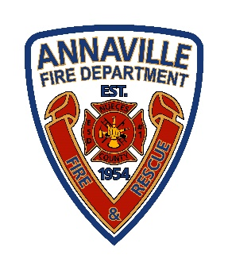 **Nueces County Emergency Services District #1**

**Annaville Fire Department** 5241 County Road 73  
 Robstown, TX 78380 |Office (361)241-1372

**Fire Protection for “No Man’s Land” in Nueces County**

Some areas of Nueces County currently **don’t have dedicated fire or EMS service**. These areas, often called **“No Man’s Land,”** rely on nearby fire departments—like **ESDs**, **Robstown**, or **Corpus Christi**—when available, but coverage is inconsistent.

To provide reliable protection, **ESD 1, ESD 3, and ESD 4** residents have petitioned the ESD’s in the unprotected areas to join **their district** through annexation.

**How the Annexation Vote Works**

1. **Residents in the proposed area** vote on whether they want to join the ESD.
2. **Residents already in the ESD** vote on whether to accept the new area.
3. **Both votes must pass** for the annexation to happen.

**Elections are scheduled for the November ballot.**

**Why Residents Are Considering Annexation**

* **Better insurance access:** Many homes in unprotected areas have trouble getting insurance or face high premiums.
* **Faster emergency response:** Joining an ESD ensures a clear, assigned fire and EMS provider.
* **Cost vs. benefit:** Property taxes for ESD coverage may be less than potential insurance savings.  
  *(Note: ESD membership does not guarantee lower insurance rates; check with your provider.)*

**Property Tax Facts**

* **Maximum ESD tax:** $0.10 per $100 of property value
  + $100,000 home = $100/year | $500,000 home = $500/year

Joining an **ESD** helps ensure your home and community have **reliable fire and emergency protection**.

**Fire Chief Michael Clack  
Nueces County ESD #1 /Annaville Fire Department**5241 County Road 73 | Robstown, TX 78380  
Office (361)241-1372 | [chief@annavillefire.com](mailto:kluckenbach@ncesd1.org)